**A PROPOSED OFFERING OF PAYROLL**

**SYSTEM FOR WILLTOP HARDWARE AND ELECTRICAL SUPPLIES**

A Project Proposal Presented to the

Faculty of Datamex College of Saint Adeline, Inc.

In Partial Fulfillment of the Requirements for the

Degree of Bachelor of Science in Information Technology

**Prepared By:**

Ablola, Carlo

Bernadez, Brian R.

September 2025

**DESIGN DOCUMENTATION**

**INTRODUCTION**

This document explains the Payroll System for WILLTOP Hardware and Electrical Supplies. The system is made to help the store owner manage payroll faster and more accurately.

The purpose of this document is to describe the Payroll System for WILLTOP and Electrical Supplies. The system is designed to make payroll easier by providing accurate salary computations, organized employee records, and payroll reports. Payroll is one of the most important functions in a company, and this system will help reduce errors, save time, and ensure that employee information is handled properly.

This document is intended for the developers who will create and maintain the system, the company store owner who will oversee its use, and the employees who will interact with it. For developers, it serves as a guide in building the system according to the required functions. For store owner, it explains how the system will improve payroll operations. For employees, it shows how their information and salaries will be managed in a reliable way.

The Payroll System will handle important tasks such as calculating salaries based on attendance and working hours, recording employee details, monitoring overtime and deductions, and generating payroll reports. By these processes, the store owner can avoid delays and mistakes that often occur in manual payroll systems, ensuring that salaries are processed correctly and on time.

This document provides a reference for the design, development, and use of the Payroll System. It ensures that the system fits the needs of WILLTOP and Electrical Supplies, improves payroll efficiency, and supports both store owner and employees in carrying out their responsibilities effectively.

**Overview of the software being designed**

The system helps manage employee information and payroll easily. It lets store owner add, update, or remove employee details like name, position, contact information, and hourly rate, keeping all data organized. The system also monitors daily work hours, including regular and overtime hours, and automatically calculates wages based on the hours worked and set rates. For payroll, it figures out total salaries by including deductions, bonuses, and overtime pay, and creates payroll summaries and individual salary statements for each employee. It can also make reports and keeps past payroll records for reference of owner.

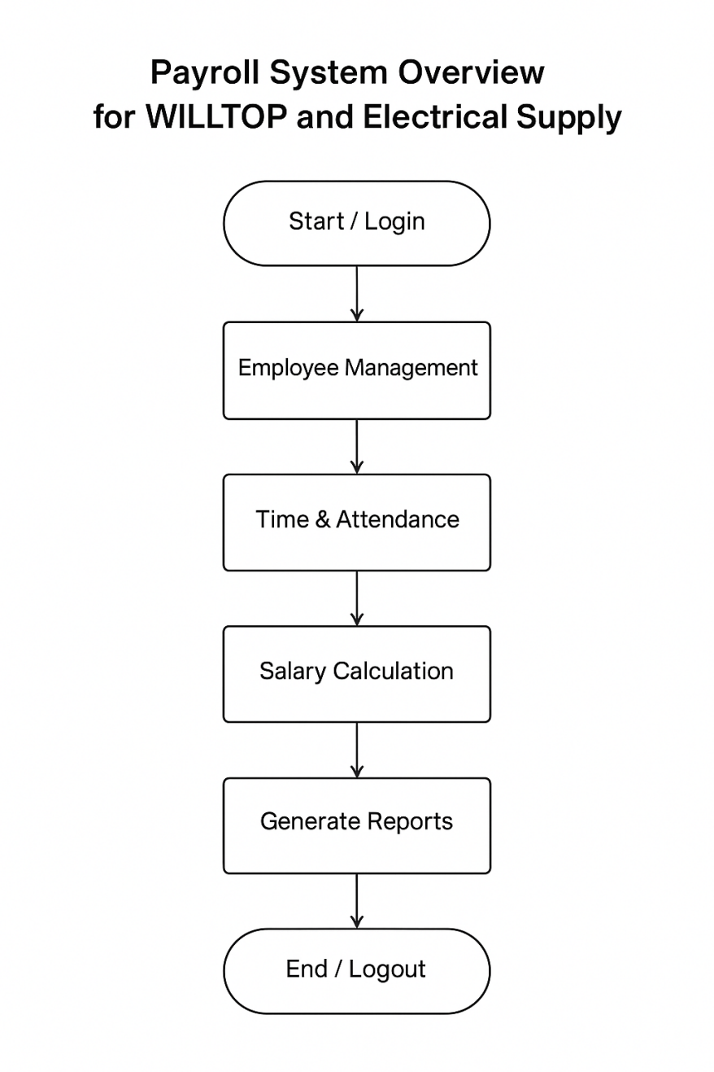

*Image 1. Flow of the system*

**Scope of the design document**

This design document covers the development of an Employee and Payroll System. The system is intended to help store owner efficiently manage employee information, monitor work hours, and process payroll. It includes features such as adding, editing, and removing employee details, recording regular and overtime hours, and calculating total salaries with deductions, bonuses, and overtime pay. The system also generates payroll summaries, individual salary statements, and reports for store owner and employee purposes.

**The scope of the system includes:**

**Employee** – Maintaining a database of employee records with personal and job-related information.

**Time and Attendance Monitoring** – Recording daily work hours and automatically calculating wages.

**Payroll Processing** – Computing salaries, deductions, bonuses, and overtime pay, and generating payroll statements.

**Reporting and Record-Keeping** – Producing reports and storing historical payroll data for auditing and reference.

The system does **not** handle other human resource tasks like recruitment, performance evaluation, or employee benefits beyond payroll.

**SYSTEM ARCHITECTURE**

The Payroll System is designed to manage employee information, monitor attendance, and process payroll efficiently. The system is built using **Visual Basic 2010** for the client application and **SQL Server** (via SSMS) for the database. It follows a **client-server architecture**, where the client application interacts with the database server to retrieve, update, and store employee and payroll information.

**High-Level Components and Interactions**

**Client Application (Visual Basic 2010)** – Provides the user interface for store owner to manage employee records, monitor attendance, calculate salaries, and generate payroll reports.

**Database Server (SQL Server)** – Stores all employee details, work hours, payroll calculations, and historical data for record-keeping and auditing.

**Application Logic** – Embedded in the client application; it handles payroll calculations such as total salary, deductions, bonuses, and overtime, as well as data validation before sending updates to the database.

**Reporting Module** – Uses data from the database to generate payroll summaries, individual salary statements, and payroll reports.

**Deployment Architecture**

**The system uses a client-server deployment model:**

* The **client** runs the Visual Basic 2010 application on local computers.
* The **server** hosts the SQL Server database, which can be located on a local network or remote server.
* The client communicates with the server over the network to perform all database operations, ensuring centralized data management.

**Communication Protocols and Interfaces**

* The client communicates with the SQL Server database using **ADO.NET** over **TCP/IP**.
* The interface between the client and the database is structured using SQL queries and commands to perform operations such as inserting, updating, deleting, and retrieving records.
* The system interface is simple and user-friendly, allowing store owner to manage payroll tasks without direct interaction with the database.

# DATABASE DESIGN

## Entity-Relationship Diagram (ERD)

The diagram below shows the database schema of the Payroll System. Each entity is represented as a box with its attributes listed inside. Primary Keys (PK) and Foreign Keys (FK) are marked, and straight connectors show one-to-many relationships.

## 

## *Image 2. Entity Diagram (ERD)*

## Database Tables

Each table’s fields and key details are listed below.

### Employee

|  |  |  |
| --- | --- | --- |
| Field | Data Type | Notes |
| EmployeeID (PK) | INT | Primary Key, Identity |
| Name | VARCHAR(100) | Required |
| Position | VARCHAR(50) | Required |
| Address | VARCHAR(255) | Optional |
| Contact | VARCHAR(20) | Optional |
| HourlyRate | DECIMAL(10,2) | Required |

*Table 1. Employee ERD*

### Attendance

|  |  |  |
| --- | --- | --- |
| Field | Data Type | Notes |
| AttendanceID (PK) | INT | Primary Key, Identity |
| EmployeeID (FK) | INT | FK Employee(EmployeeID) |
| Date | DATE | Required |
| TimeIn | DATETIME | Required |
| TimeOut | DATETIME | Nullable (open shift) |
| TotalHours | DECIMAL(5,2) | Computed/Stored |
| OvertimeHours | DECIMAL(5,2) | Computed/Stored |

*Table 2. Attendance ERD*

### Payroll

|  |  |  |
| --- | --- | --- |
| Field | Data Type | Notes |
| PayrollID (PK) | INT | Primary Key, Identity |
| EmployeeID (FK) | INT | FK -> Employee(EmployeeID) |
| PayPeriod | VARCHAR(20) | e.g., '2025-08-01 to 2025-08-15' |
| BasicPay | DECIMAL(10,2) | From hours × rate |
| OvertimePay | DECIMAL(10,2) | From OT hours × OT rate |
| TotalDeductions | DECIMAL(10,2) | Sum of deductions |
| TotalBonuses | DECIMAL(10,2) | Sum of bonuses |
| NetPay | DECIMAL(10,2) | Basic + OT + Bonuses − Deductions |

*Table 3. Payroll ERD*

### Deductions

|  |  |  |
| --- | --- | --- |
| Field | Data Type | Notes |
| DeductionID (PK) | INT | Primary Key, Identity() |
| PayrollID (FK) | INT | FK -> Payroll(PayrollID) |
| DeductionType | VARCHAR(50) | e.g., Tax, SSS, Loan |
| Amount | DECIMAL (10,2) | Required |

*Table 4. Deductions ERD*

### Bonuses

|  |  |  |
| --- | --- | --- |
| Field | Data Type | Notes |
| BonusID (PK) | INT | Primary Key, Identity() |
| PayrollID (FK) | INT | FK -> Payroll(PayrollID) |
| BonusType | VARCHAR(50) | e.g., Incentive, Allowance |
| Amount | DECIMAL(10,2) | Required |

*Table 5. Bonuses ERD*

**Relationships**

* Employee → Attendance: One employee has many attendance records (1..*).
* Employee → Payroll: One employee has many payroll records (1..*).
* Payroll → Deductions: One payroll record can have many deduction rows (1..*).
* Payroll → Bonuses: One payroll record can have many bonus rows (1..*).

## Normalization

The schema follows standard normalization up to Third Normal Form (3NF):

1. 1NF: All attributes are atomic (e.g., separate TimeIn and TimeOut fields).

2. 2NF: Non-key attributes depend on the whole key (each table has a single-column PK).

3. 3NF: No transitive dependencies (Bonuses and Deductions separated from Payroll).

**USER INTERFACE DESIGN**

Our UI/UX Design is made up of Guna Framework.

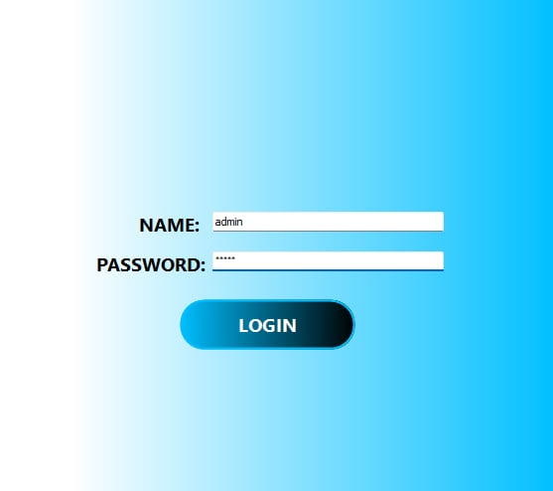**LOG IN FORM** – THEUSER WILL ALLOW TO LOG IN INTO SYSTEM**.**

## *Image 3. LOGIN FORM*

**DASHBOARD -** THE USER WILL ALLOW TO CHECK THE EMPLOYEES HERE ACCORDING TO THE DUTIES.

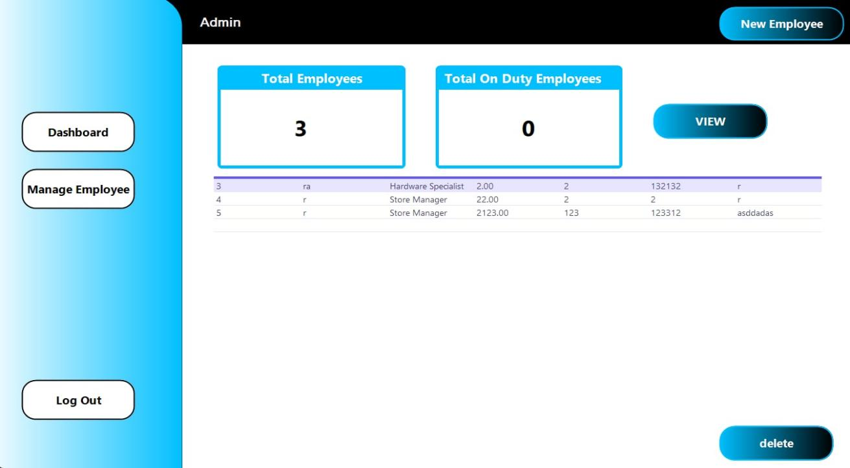

## *Image 4. DASHBOARD*

**ADD EMPLOYEE -** THE USER IS ALLOWED TO ADD NEW EMPLOYEES AND ALSO IT WILL INDICATTE THE INFORMATIONS OF THE EMPLOYEE. IT WILL INDICATE THE GIVEN RATE PER HOUR.

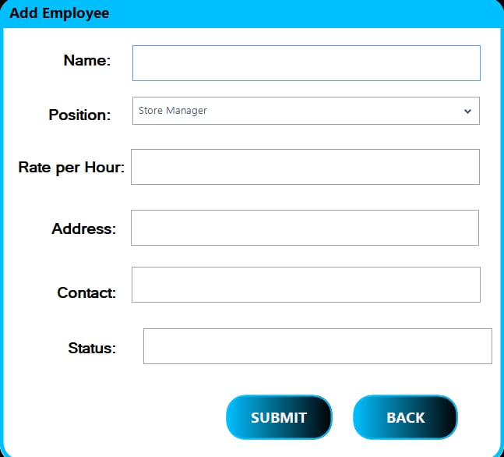

## *Image 5. ADD EMPLOYEE*

**EDIT TIME AND DATE -** IN THIS PART, THE USER IS ALLOWED TO INPUT THE TIME IN AND TIME OUT OF THEIR EMPLOYEE.

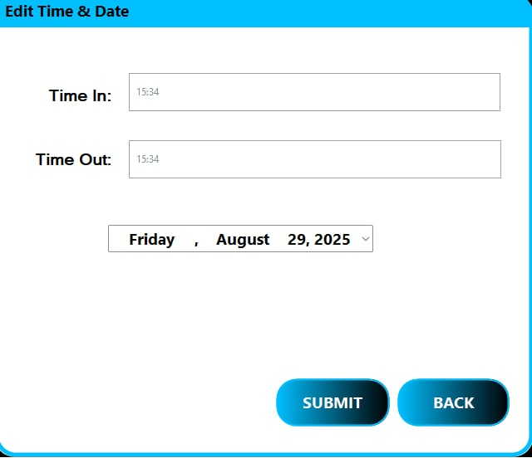

## *Image 6. EDIT DATE AND TIME*

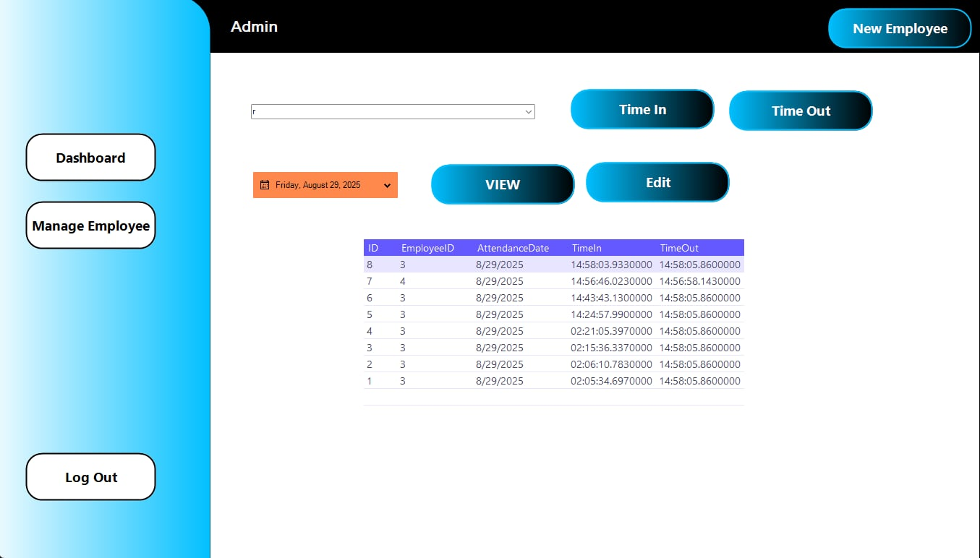**MANAGE EMPLOYEE -** THE USER OF THIS SYSTEM CAN MANAGE ALL THE EMPLE INSIDE THE SYSTEM.

## *Image 7. MANAGE EMPLOYEE*

**TIME IN / OUT -** THE USER WILL MONITOR THE TIME IN AND OF THE EMPLOYEE

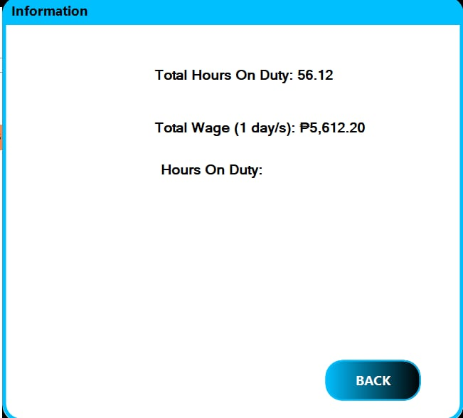

## *Image 8. TIME IN AND OUT*

**COMPONENTS AND DESIGN**

## The Payroll System for WILLTOP Hardware and Electrical Supplies is built with several modules that work together to manage employee and payroll information.

**Employee Module**

* VB Forms handle input (employee name, position, rate/hour, status).
* SQL Server tables store employee records.

**Attendance & Timekeeping Module**

* VB Forms log daily attendance, overtime, absences.
* Stored in Attendance table inside SQL Server.

**Payroll Calculation Module**

* Written in VB (business logic).
* Reads Employee + Attendance data from SQL, applies formulas (salary, deductions, overtime).

**Deduction & Benefits Module**

* VB handles logic for computing government deductions (SSS, PhilHealth, Pag-IBIG, Tax).
* Values are stored in Deductions table.

**Report Generation Module**

* Uses VB Crystal Reports / built-in reporting tool to display.
* Payslips per employee.
* Payroll summary.
* Deduction reports.

**User Authentication Module**

* Login form in VB.
* Credentials stored in SQL Server (Users table).
* Role-based access (Admin, HR, Accountant).

**Database Module (SQL Server 2008/2012)**

* Tables: Employees, Attendance, Payroll, Deductions, Users.
* Ensures data consistency, indexing, and relationships.

## Dependency Management & Interactions

**VB Forms (Front-End)** = Collects input and displays output.

**Business Logic (VB Functions)** = Computes payroll, deductions, and generates reports.

**SQL Server Database** = Stores persistent data (Employees, Attendance, Payroll, Users).

**Interaction Flow Example (Payroll Process):**

System calculates payroll **→ VB Payroll Function → Employees + Attendance + Deductions Tables (SQL).**

Payslips generated **→ VB Report Viewer / Crystal Reports → Payroll Table (SQL).**

Admin reviews report offline **→ VB Reporting Module → SQL Database.**

**DATA FLOW DIAGRAMS**

The Data Flow Diagrams show how information moves through the Payroll System of WILLTOP Hardware and Electrical Supplies. They explain the roles of the store owner, employees, and government agencies, as well as how data is processed inside the system.

## ****Context Diagram (Level 0 DFD)****

**Entities (External Sources/Destinations):**

**Store Owner** → enters employee data, attendance, requests reports.

**Employee** → provides attendance, receives payslips.

**Government Agencies (SSS, PhilHealth, and Pag-IBIG)** → receive deduction reports.

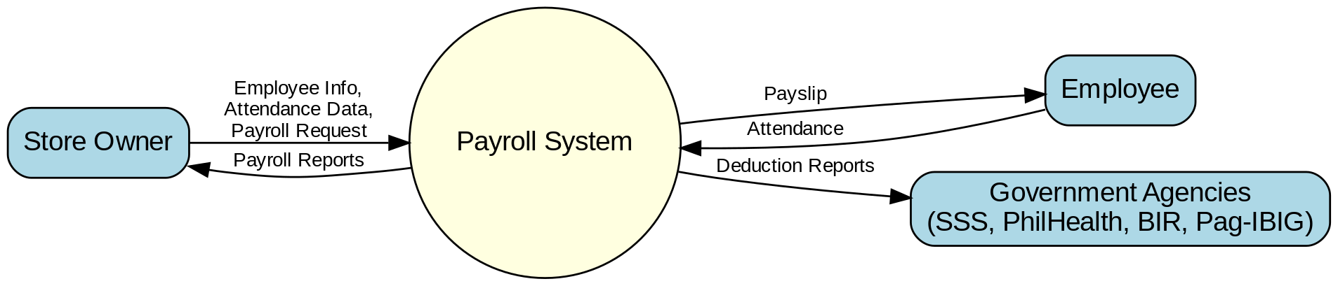

## *Image 9. LEVEL 0 DFD.*

**Data Flows:**

* Store Owner inputs employee info & attendance.
* System calculates payroll & deductions.
* Employees receive payslips.
* Store Owner receives payroll reports.
* Government receives deduction summaries.

## ****Level 1 DFD (Main Processes)****

**Processes:**

**Manage Employee Records**

Input: Employee details

Output: Employee database updates

**Record Attendance**

Input: Daily attendance (time-in, time-out)

Output: Attendance stored in database.

**Compute Payroll**

Input: Employee data + Attendance + Deductions rules

Output: Payroll records

**Generate Reports & Payslips**

Input: Payroll records

Output: Payslips, payroll summary, deduction reports.

**Data Stores:**

* **Employees Table**
* **Attendance Table**
* **Payroll Table**
* **Users Table (only for Store Owner login)**

**External Entities:**

* Store Owner
* Employee
* 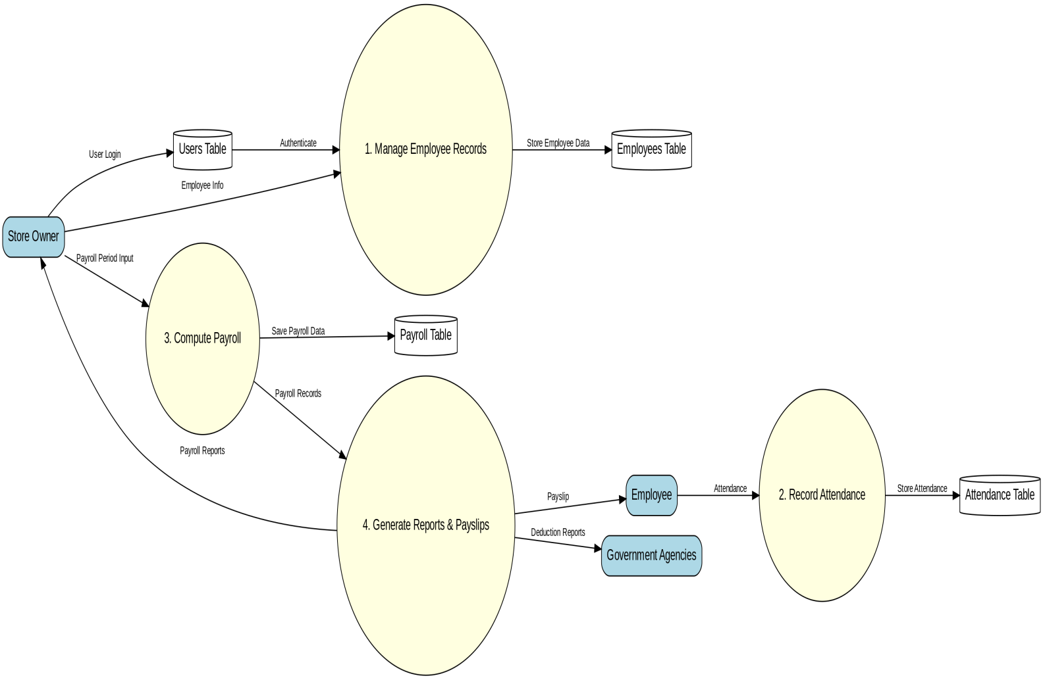Government Agencies

## *Image 10. LEVEL 1 DFD.*

**Process 3: Compute Payroll (expanded)**

**Input Data Sources:**

Employee info (rate/hour, position, status) → from **Employees Table**

Attendance (time-in, time-out, overtime) → from **Attendance Table** Deduction rules (SSS, PhilHealth, and Pag-IBIG) → from **Deductions Table**

**Processing Logic:**

Calculate **Gross Pay = Total Hours × Rate per Hour + Overtime**

Apply **Deductions = SSS + PhilHealth + Pag-IBIG + Tax**

Compute **Net Pay = Gross Pay – Deductions + Benefits**

**Output Destinations:**

**Payroll Table** (stores computed payroll)

**Payslip** (for employee)

**Payroll Report** (for Store Owner)

**Government Reports** (for agencies)

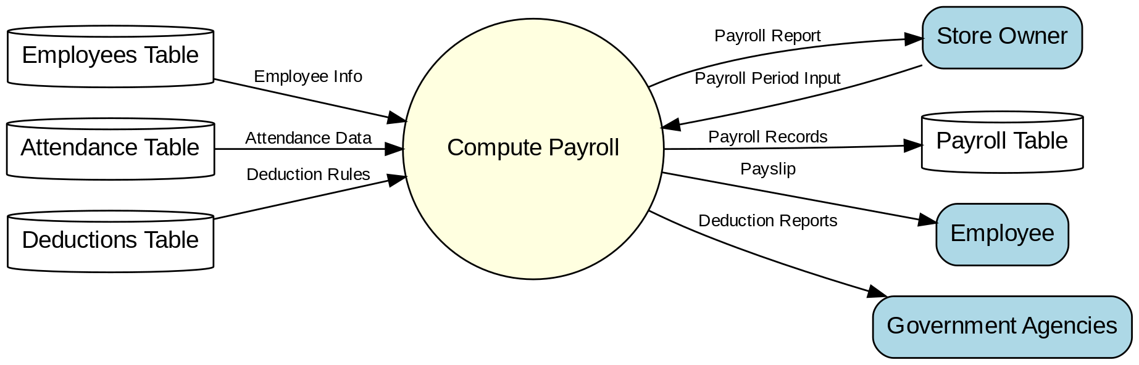

## *.*

*Image 11. LEVEL 2 DFD*

**SECURITY DESIGN**

The Payroll System for WILLTOP Hardware and Electrical Supplies deals with sensitive information such as employee records, salaries, attendance, and government deductions.

## 1. Overview of Security Needs

**The system stores sensitive data such as:**

* Employee details (name, position, contact info).
* Salary, attendance, and payroll records.
* Government deductions (SSS, PhilHealth, and Pag-IBIG).

**Because this information is private, the system must protect it against:**

* **Unauthorized access -** (only the Store Owner can use the system).
* **Data loss -** (from system errors, power failure, or accidental deletion).
* **Data theft** - (someone trying to copy the database or reports).

## 2. Authentication and Authorization

* The system has **only one user account: the Store Owner**.
* The Store Owner logs in with a **username and password**.
* The password is stored **securely** (not in plain text, but converted into a hash code before saving).

**Only the Store Owner has permission to:**

* Add/update employee records
* Input attendance
* Generate payroll and deductions
* Create reports and payslips
* **No other users or staff accounts exist.**

## 3. Data Encryption and Protection

**Database Security:**

* The SQL Server database is protected so only the Payroll System program can access it.
* The database or backup folder can be stored in a drive protected by **Windows Bit Locker** or a similar encryption tool.

**Backups:**

* Payroll data is backed up regularly (e.g., weekly or monthly).
* Backup copies are stored in a **password-protected USB or external drive**.
* Backups are tested to make sure they can be restored.

**System Files and Reports:**

Exported reports (like payroll summaries or payslips) should be stored in a **locked or password-protected folder**.

## Other Security Measures

**Input Validation:** The program checks data entered (e.g., no letters in salary fields, no empty employee names).

**Error Handling:** The system avoids showing raw error codes and instead gives clear error messages.

**System Maintenance:**

* The computer should have **antivirus software**, windows and SQL Server should be updated regularly.
* Only the Store Owner should have access to the computer where the system is installed.

# PERFORMANCE DESIGN

The Payroll System for WILLTOP Hardware and Electrical Supply is designed to be fast, reliable, and easy to use.

## 1.Performance Requirements and Objectives

**The payroll system is used only by the store owner. It must:**

* Work **fast and smooth** when adding employees, calculating payroll, and viewing reports.
* Handle up to **200 employees** without slowing down.
* Generate reports (payslips, summaries) in just a few seconds.
* Run on a **standalone computer** without internet or network.

## 2. Strategies for Good Performance

To keep the system quick and reliable:

**Efficient Database**

* SQL Server tables use indexes to make searching and calculations faster.
* Old data can be archived to keep the database light.

**Fast Program Design**

* Visual Basic forms are kept simple so they load quickly.
* The system temporarily stores commonly used data (like employee lists) to avoid repeated loading.

**Local Setup**

Since the system is offline and only runs on one computer, there are no delays from internet or networking.

**Maintenance**

Regular database cleanup and backups keep the system stable.

## 3. Performance Testing Plan

Before full use, the system will be tested to ensure speed and reliability:

**Speed Test** – Check how fast it responds when logging in, adding records, and generating payroll (goal: under 3 seconds).

**Load Test** – Add up to 200 employees and process payroll; system should stay smooth.

**Report Test** – Generate large payroll reports quickly without errors.

**Stability Test** – Run the system for many hours; it should not slow down or crash.

**Backup Test** – Ensure data can be backed up and restored without affecting performance.

## ERROR HANDLING AND LOGGING

The Payroll System for WILLTOP Hardware and Electrical Supplies includes error handling and logging to make sure it runs smoothly and safely. Error handling prevents the system from crashing by checking inputs, protecting the database, and using warning messages when something goes wrong. Visual Basic also uses Try Catch to handle unexpected errors.

## Error Handling Strategies

The payroll system must keep running smoothly even when mistakes happen. To do this:

**Input Checking**

The system checks if the Store Owner enters correct information.

Example: Rate per hour must be numbers, contact number must have digits only.

If the input is wrong or missing, the system shows a warning message.

**Database Protection**

If the system cannot connect to the SSMS database, it will stop the action and show a clear message instead of crashing.

Example: “Cannot connect to database. Please restart the system.”

**Payroll Calculation Checks**

The system makes sure that calculations (like hours × rate) are done correctly.

If data is incomplete, the system will alert the Store Owner to fix the record first.

**System Safety**

Visual Basic uses Try Catch to handle unexpected errors.

This prevents the program from closing suddenly.

## Logging Requirements

To help the Store Owner track problems and actions, the system keeps logs:

**Error Log File**

All system errors are saved in a text file (e.g., ErrorLog.txt).

Each entry shows the Date, Time, Error Code, and Error Message.

**Database Activity Log**

Important actions like adding, updating, or deleting employees and payroll are recorded in a database table.

This helps the Store Owner review past changes if needed.

**Login Log**

Every login attempt is recorded with date and time.

Failed login attempts are also saved for security.

# Payroll System - Error Codes and Messages

|  |  |  |
| --- | --- | --- |
| **Code** | **Message** | **When it Happens** |
| E001 | Database connection failed | When the system cannot connect to the SSMS database. |
| E002 | Invalid employee ID | When the entered employee ID does not exist. |
| E003 | Salary computation error | If there is a problem during payroll calculation. |
| E004 | Data not found | When requested data is missing or deleted. |
| E005 | Unexpected system crash | When the program encounters an unknown error. |

*Table 6. Error Codes and Messages.*

**THIRD-PARTY INTEGRATIONS**

The Payroll System for WILLTOP Hardware and Electrical Supplies is an offline application, so it does not rely on online services or external APIs. Instead, it can integrate with third-party tools in limited ways, such as using SQL Server backup software to secure payroll data and exporting reports or payslips in PDF format. These integrations are done manually to keep the system simple and fit the client’s needs.

**Description of Integration Points**

The Payroll System for WILLTOP and Electrical Supplies is designed as a **standalone, offline system** using Visual Basic 10 for the application and SQL Server Management Studio (SSMS) for the database. Because it is offline, the system does **not directly connect to online services or external APIs**. However, there are certain points where integration with third-party tools may be useful:

**Backup and Restore**

Since the database is stored in SSMS, the store owner can use **SQL Server backup tools** or third-party backup software to keep a safe copy of the payroll records.

**Data Exchange Formats**

**PDF (.pdf):** For finalized reports, payslips, or records that should not be edited.

**Considerations**

All integrations are kept **manual and offline** (for example, exporting reports, running backups), since the client does not require an internet-based system.

**DEPLOYMENT PLAN**

The Payroll System for WILLTOP Hardware and Electrical Supplies will be installed on a single computer owned by the store owner. Since it is an offline system, the deployment process is simple, requiring only the setup of SQL Server for the database and the installation of the Visual Basic application.

The system is designed to run on basic hardware with Windows 10 or 11 and uses SQL Server Management Studio for database management. Backups, updates, and version control will be handled manually by the store owner to keep the system secure and reliable.

## 1. Overview of the Deployment Process

The Payroll System for WILLTOP and Electrical Supplies will be installed and used on a **single standalone computer** owned by the Store Owner. Since the system is offline and does not require internet or a network, deployment is simple and direct:

* Install **SQL Server Management Studio (SSMS)** for the database.
* Restore or create the payroll database in SSMS.
* Install the **Payroll System application (Visual Basic .exe file)** on the computer.
* Connect the application to the local SQL Server database.
* Test the system by adding employee data and generating a sample payroll.
* Provide the Store Owner with a backup file of the database for recovery.

## 2. Hardware and Software Requirements

### Hardware (Minimum Requirement – Store Owner’s Computer)

* **Processor:** Intel i3 or higher
* **RAM:** 4GB or higher
* **Storage:** At least 250GB hard drive (with 2GB free for database and backups)
* **Display:** Standard monitor (1366x768 or higher resolution)
* **Other:** Keyboard, mouse, and printer (optional for payslips)

### Software

* **Operating System:** Windows 10 and 11 (64-bit recommended)
* **Database:** Microsoft SQL Server (SSMS) 2008 or higher
* **Application:** Visual Basic 2010 runtime environment
* **Office Tools (Optional):** Microsoft Excel (for exported reports), Adobe Reader (for PDF reports)

## 3. Configuration Management and Version Control Procedures

Since the system is used only by the Store Owner on one computer, configuration and version control will be **simple and manual**:

**Version Control:**

* Each new version of the Payroll System will be saved with a version number (e.g., PayrollSystem_v1.0.exe, PayrollSystem_v1.1.exe).
* Old versions will be archived for reference in case rollback is needed.

**Database Configuration:**

* The database name and connection string will be set up during installation.
* Configuration will be saved in a text/config file so it can be changed if needed.

**Backups:**

* The Store Owner will create **regular database backups (.bak files)** using SSMS.
* Backups will be stored on the same computer or an external USB drive.

**Updates:**

* If the system is updated, the Store Owner will install the new version manually by replacing the old .exe file.
* A copy of the database will be kept safe before updates.

**MAINTENANCE AND SUPPORT**

The Payroll System for WILLTOP Hardware and Electrical Supplies requires simple but regular maintenance to keep it running properly. Since it is installed on one computer and used only by the store owner, tasks like database backups, system updates, and hardware care are important for smooth operation.

## Guidelines for System Maintenance

Since the system runs on one standalone computer and is used only by the Store Owner, maintenance is simple but important.

**Database Maintenance**

* Regularly back up the payroll database in SSMS (e.g., once a week or before payroll processing).
* Archive old records yearly to keep the database light and fast.

**System Maintenance**

* Keep the Visual Basic application file (PayrollSystem.exe) in a safe folder.
* Do not delete or rename database files in SQL Server.
* Ensure the computer has updated antivirus protection to avoid corruption.

**Hardware Care**

* Maintain the computer by cleaning up unnecessary files and running disk checks.
* Ensure there is enough storage space for reports and backups.

## Software Updates, Patches, and Bug Fixes

Updates and fixes will be done manually since the system is offline.

**Updates**

* New features or improvements will be released as a new version of the application file (e.g., PayrollSystem_v1.1.exe).
* The old version will be kept in a backup folder in case rollback is needed.

**Patches and Fixes**

* If errors or bugs are found, a patched version will be provided.
* The Store Owner will replace the old .exe file with the patched one.

**Database Safety**

After updating, the database will be reconnected to the new application version.

## Escalation Process for Resolving Issues

If problems happen, the following steps should be followed:

**Minor Issues (Handled by Store Owner)**

* Check input errors (e.g., wrong data format, missing fields).
* Restart the system and retry the action.
* Review error messages for guidance.

**Moderate Issues (Handled with Support)**

If the system fails to connect to the database or reports do not generate, the Store Owner should contact the developer or IT support.

Provide the error message and a copy of the error log file (ErrorLog.txt).

**Serious Issues (Escalation)**

For system crashes, corrupted database, or lost data:

* Restore the latest database backup (.bak file) in SSMS.
* If unresolved, escalate to the software developer for troubleshooting and patch release.

**REVISION HISTORY**

The revision history shows the list of changes made in this payroll system documentation for WILLTOP Hardware and Electrical Supplies.

|  |  |  |
| --- | --- | --- |
| August 14, 2025 | Introduction, Objectives of the project, Goals of the project, Client information and Project scope. | Revision of not consistent format, information's, fonts and we fix all of words. |
| August 18, 2025 | Project timeline, Project approach, and Risk management. | Revision of all these parts from the words, figure table, and also the proper format. |
| August 20,2025 | Communication plan | Revision of all the parts of communication plan according to the given flow of the system. |
| August 22,2025 | Project Governance, Approval, Appendix | Fixing all the format and also the font size and style. |

*Table 7. Revision History*

**APPENDIX**

* **Visual Basic Language Reference** (official documentation from Microsoft):  
  [https://learn.microsoft.com/en-us/dotnet/visual-basic/language-reference/](https://learn.microsoft.com/en-us/dotnet/visual-basic/language-reference/?utm_source=chatgpt.com)
* **Minimum Wage in the Philippines** (overview of wage-setting and regional differences):  
  [https://laborlaw.ph/minimum-wage/](https://laborlaw.ph/minimum-wage/?utm_source=chatgpt.com)
* **Department of Labor and Employment (DOLE), Philippines** (policy authority and labor law updates):  
  [https://en.wikipedia.org/wiki/Department_of_Labor_and_Employment_%28Philippines%29](https://en.wikipedia.org/wiki/Department_of_Labor_and_Employment_(Philippines)?utm_source=chatgpt.com)